43.19: a) If tritium is to be unstable with respect to 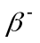decay, then the mass of the products of the decay must be less than the parent nucleus.
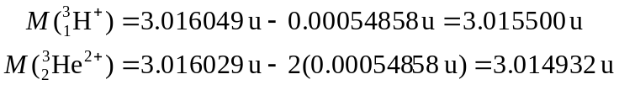
so the decay is possible.
b) The energy of the products is just

